Puzzle - Serial RF Pro

Introduction
Puzzle-Serial RF Pro is a low cost, high performance transparent FSK transceiver with operating at 433/470/868/915 MHz, and the best performance is at 433M(Default). There is a UART interface that is easy to realize the wireless data transmission with only providing the UART data. It is flexible for the users to set the UART baud rate, frequency, output power, data rate, frequency deviation, receiving bandwidth etc parameters. It is your ideal choice for designing wireless data transmission products which can be widely used on wireless data transmission field.

Features
- Puzzle compatible
- High output power
- High output power
- Small size
- Longer transmission distance

Application Ideas
- Remote control, remote measurement system
- Wireless meter
- Access control
- Identification system
- Data collection
- IT household appliance
- Baby monitoring system

Specification
Item | Min | Typical | Max | Unit
Working Voltage | 4.75 | 5.0 | 5.25 | VDC
Current at sleep mode | 1 |  |  | uA
output power | 1 | - | 20 | dB
Communication Speed | 1.2 | - | 115.2 | Kbps
Transmission Distance(Max) | 1 |  |  | Km
Sensitivity | -117 |  |  | dBm
Communication Protocol | UART |  |  | /
Operate Temperature | -40 | - | +85 | ℃

Interface Function

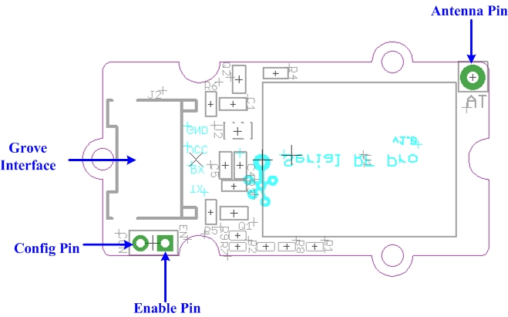
x
Pad Type (5V Logic level) | Description
G(GND) | Ground port
EN(ENABLE) | Set low for normal mode as data transceiver (Default is low with 10k to GND).  Set high to put into sleep mode.
CON(CONFIG) | Set low for configuration mode (connect to GND).  Set high for communication (Default is high).
RX | UART Data input
TX | UART Data output
V(VCC) | Designed for 5V(+)supply
AT | Antenna pin

Usage
Here we show two RF Pro Puzzle units mutually transmitting/receiving data. You need two RF Pro Puzzle units and two duinofun to do the demo.
- Connect one Puzzle - Serial RF Pro to UART of Puzzle - Base Shield and plug Puzzle - Base Shield into duinofun.
- Connect another Puzzle - Serial RF Pro to duinofun using the same method.

Config and Inquiry methods
The module will be ready for Config status if ENABLE pin is low, CONFIG pin is low. It will be in Config if the red and green LED keep lighting. Then you can Config & inquiry on the module.
- Connect CON pin to LOW/GND to enter configure mode.
- Send command to modify and query the config of the module.Config& Inquiry instruction description see Reference.
The Config instruction format is as AA+FA+[instruction]+[parameter]. The instruction is 1 byte, the parameter is the HEX data of 0-4 bytes (in big-endian ordering, with the high byte before the low byte).
Note:
1) Do remember the UART transfer speed(default is 9600, better not change) if you make some change, or you won't be able to control the module. The instruction’s transfer speed will change accordingly if changes the transfer speed of UART. The range of transfer speed of the instruction is from 1.2Kbps – 115.2K bps.
2) LED Function Description:
The red and green LED will flash when there is power and the module is working.
The module will be ready for configuration mode if EN(ENABLE) pin is low(default is low)，CON(Config) pin is low. When in configuration mode, the red and green LED will both be solidly lit. The green and red LED will not be solidly lit if the module is not in configuration mode.
The red LED flash when the module is transmitting, the red LED will be off when the transmission is finished.
The green LED is off when the module is waiting for data to be received, the green LED will flash once when the module receives data.
Communication Mode
- Upload the below code into duinofun, Please click here if you do not know how to upload.

//send data routine

// link between the computer and the SoftSerial Shield
//at 9600 bps 8-N-1
//Computer is connected to Hardware UART
//SoftSerial Shield is connected to the Software UART:D2&D3

#include <SoftwareSerial.h>

SoftwareSerial SoftSerial(11, 10); // TX, RX
int buffer[64];
int count=0;
void setup()
{
SoftSerial.begin(9600); // the SoftSerial baud rate
Serial.begin(9600); // the Serial port of Arduino baud rate.

}

void loop()
{
delay(1000);
SoftSerial.write(0xAA);
SoftSerial.write(0xFA);
SoftSerial.write(0xE1);

if (SoftSerial.available()) // if date is comming from softwareserial port ==> data is comming from SoftSerial shield
{
while(SoftSerial.available()) // reading data into char array
{
buffer[count++]=SoftSerial.read(); // writing data into array
if(count == 64)break;
}
for (int i=0; i<count; i++) {
Serial.print(buffer[i],HEX); // if no data transmission ends, write buffer to hardware serial port
}
clearBufferArray(); // call clearBufferArray function to clear the storaged data from the array
count = 0; // set counter of while loop to zero
}
if (Serial.available()) // if data is available on hardwareserial port ==> data is comming from PC or notebook
SoftSerial.write(Serial.read()); // write it to the SoftSerial shield
Serial.println("...");
}
void clearBufferArray() // function to clear buffer array
{
for (int i=0; i<count;i++)
{ buffer[i]=NULL;} // clear all index of array with command NULL
}

- You can see as show below after open serial monitor.

Resources
- Serial RF Pro Demo Code
- the HopeRF HM-TRP Series 100mW Transceiver modules V1.0 Datasheet

